* **IMAGE NEGATIVE**

a1=double(imread('Fig0305(a)(DFT_no_log).tif'));

c1=(255-a1);

c1=mat2gray(c1);

subplot(1,2,1),imshow(a1),title('Original Image');

subplot(1,2,2),imshow(c1),title('Image Negative');

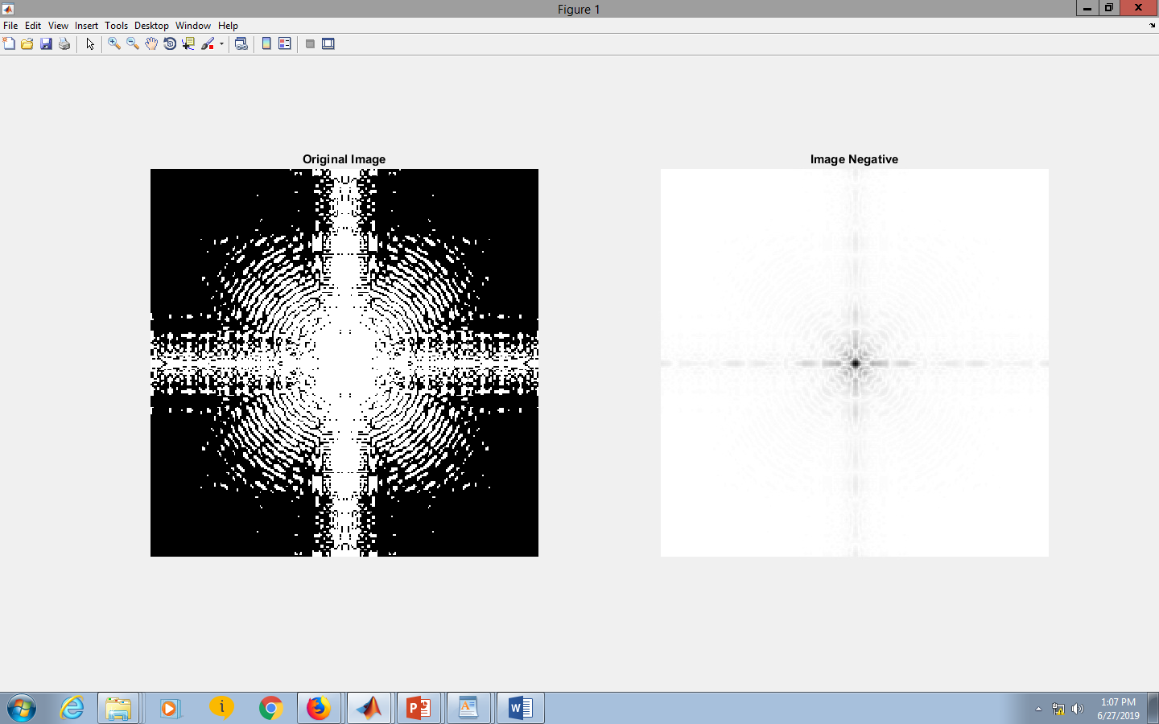

**Logarithmic transformation**

clear all;

a1=double(imread('Fig0305(a)(DFT_no_log).tif'));

b1=0.1*log(double(1+a1));

b1=mat2gray(b1);

subplot(1,2,1),imshow(a1),title('Original Image');

subplot(1,2,2),imshow(b1),title('Log transformation');

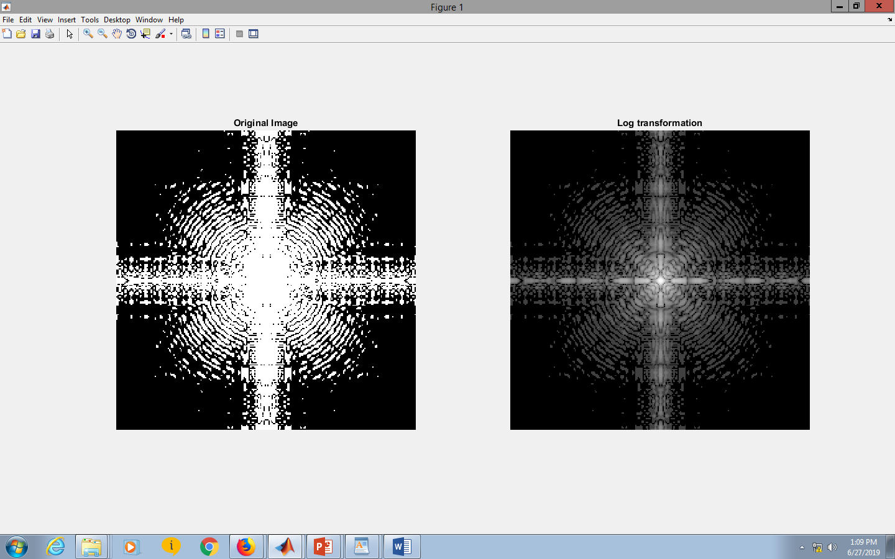

**Gamma transformation**

**FOR g<1 Dark->BRIGHT**

a2=imread('Fig0308(a)(fractured_spine).tif');

m2=im2double(a2);

c2=1;

g2=0.6; %g<1

for row=1:size(m2,1)

for column=1:size(m2,2)

if m2(row,column)>0

s2(row,column)=c2*(m2(row,column).^g2);

end

end

end

s2=mat2gray(s2);

subplot(1,2,1),imshow(m2),title('Original Image');

subplot(1,2,2),imshow(s2),title('Gamma transformation ');

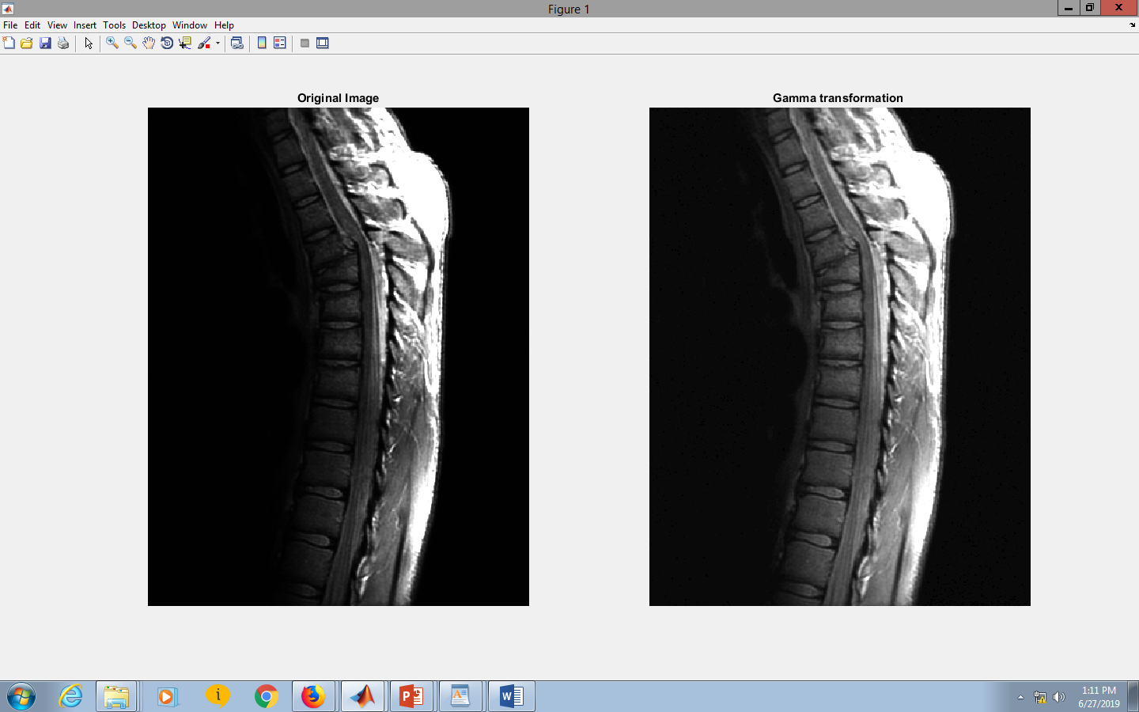

**FOR g>1 Bright->DARK**

a2=imread('Fig0309(a)(washed_out_aerial_image).tif');

m2=im2double(a2);

c2=1;

g2=4; %g>1

for row=1:size(m2,1)

for column=1:size(m2,2)

if m2(row,column)>0

s2(row,column)=c2*(m2(row,column).^g2);

end

end

end

s2=mat2gray(s2);

subplot(1,2,1),imshow(m2),title('Original Image');

subplot(1,2,2),imshow(s2),title('Gamma transformation ');

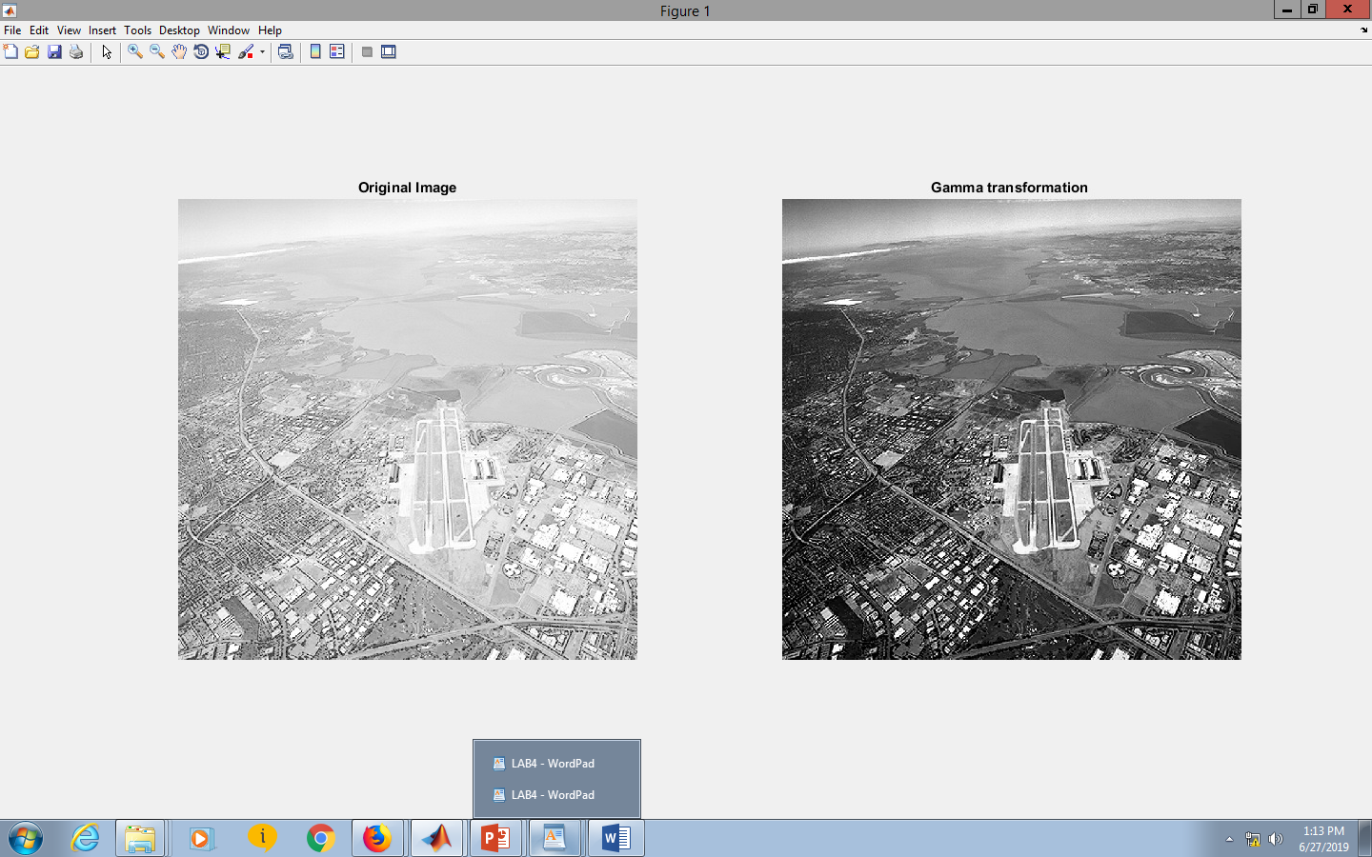

**IMADJUST :**

a3=imread('Fig0310(b)(washed_out_pollen_image).tif');

a3=im2double(a3);

s3=imadjust(a3,[0,1],[1,0]);

s3=mat2gray(s3);

subplot(1,2,1),imshow(a3),title('Original Image');

subplot(1,2,2),imshow(s3),title('Using imadjust');

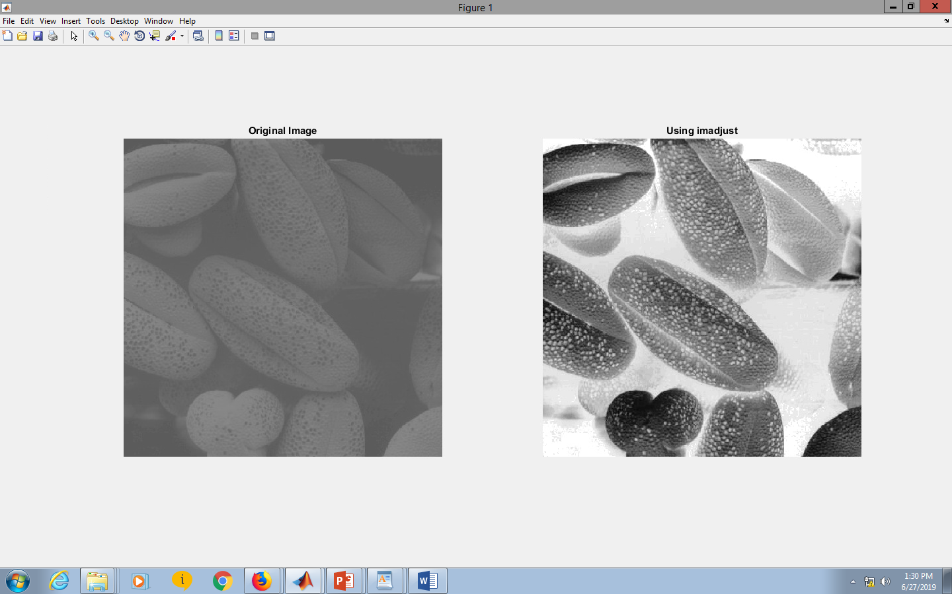

**Contrast stretching :**